# Lab: Hibernate Code First

This document defines the lab assignments for the ["Spring Data" course at Software University](https://softuni.bg/trainings/3852/spring-data-october-2022).

# 1. Vehicle Hierarchy

Your task is to **create a Vehicle hierarchy**.

### Vehicle - Abstract Class

* Has an **Id – Long**
* Has a Type - String
* Has a Model - String
* Has a Price - BigDecimal
* Has a fuelType - String

### Car

Extends from the **Vehicle** class

* Has **Seats - Integer**

### Truck

Extends from the **Vehicle** class

* Has **loadCapacity** - Double

### Bike

Extends from the **Vehicle** class

### Plane

Extends from the **Vehicle** class

* Has **passengerCapacity** - **Integer**

Use the appropriate **inheritance types** to reach **the diagrams** in the examples.

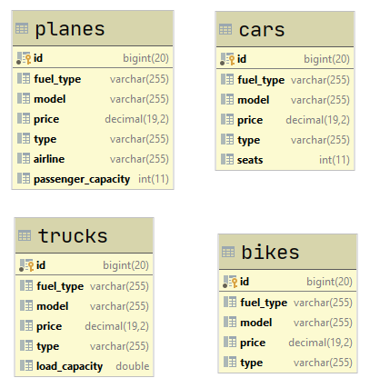

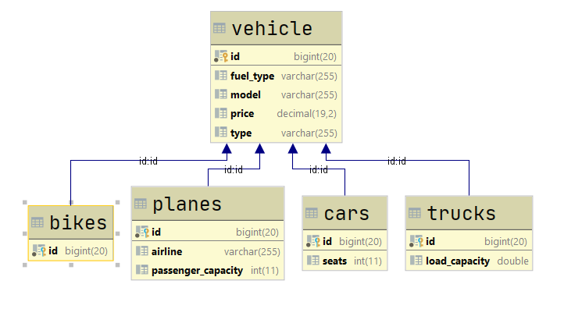

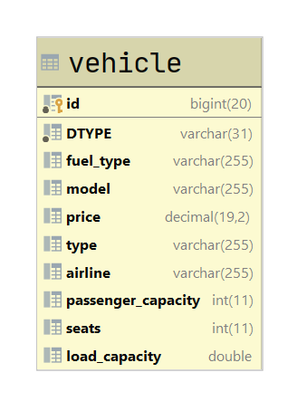

# 2. Relations

### Plate_number

* Has an **id** - **BigInteger**
* Has a **number - String**
* Has a **one to one** relations with **Cars**

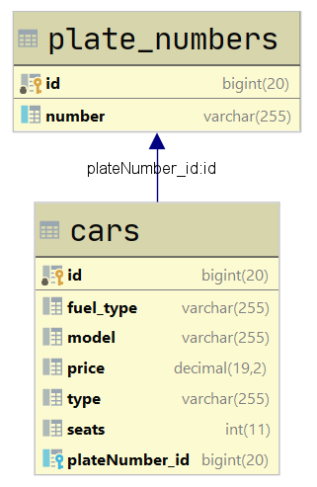

### Companies

* Has an **id** - **BigInteger**
* Has a **name - String**
* Has a **one to many** relations with **Planes**

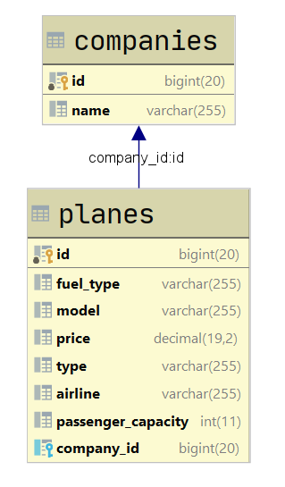

### Drivers

* Has an **id** - **BigInteger**
* Has a **full_name - String**
* Has a **many to many** relations with **Cars**

